ONEWAY Acc BY Age
/STATISTICS DESCRIPTIVES HOMOGENEITY WELCH
/PLOT MEANS
/MISSING ANALYSIS.

Oneway

Notes
Output Created |  | 05-May-2019 23:16:02
Comments
Input | Active Dataset | DataSet0
Input | Filter | <none>
Input | Weight | <none>
Input | Split File | <none>
Input | N of Rows in Working Data File | 30
Missing Value Handling | Definition of Missing | User-defined missing values are treated as missing.
Missing Value Handling | Cases Used | Statistics for each analysis are based on cases with no missing data for any variable in the analysis.
Syntax |  | ONEWAY Acc BY Age  /STATISTICS DESCRIPTIVES HOMOGENEITY WELCH  /PLOT MEANS  /MISSING ANALYSIS.
Resources | Processor Time | 00 00:00:00.157
Resources | Elapsed Time | 00 00:00:00.167

[DataSet0]

Descriptives
 | N | Mean | Std. Deviation | Std. Error | 95% Confidence Interval for Mean
 |  |  |  |  | Lower Bound | Upper Bound
18 | 1 | 120.0000 | . | . | . | .
19 | 2 | 90.5000 | 47.37615 | 33.50000 | -335.1579 | 516.1579
20 | 2 | 103.0000 | 28.28427 | 20.00000 | -151.1241 | 357.1241
21 | 2 | 89.0000 | 55.15433 | 39.00000 | -406.5420 | 584.5420
22 | 9 | 90.5556 | 26.02456 | 8.67485 | 70.5513 | 110.5598
23 | 1 | 105.0000 | . | . | . | .
24 | 1 | 115.0000 | . | . | . | .
25 | 1 | 105.0000 | . | . | . | .
28 | 2 | 117.5000 | 45.96194 | 32.50000 | -295.4517 | 530.4517
30 | 1 | 73.0000 | . | . | . | .
41 | 1 | 85.0000 | . | . | . | .
43 | 1 | 90.0000 | . | . | . | .
48 | 3 | 101.3333 | 13.05118 | 7.53510 | 68.9124 | 133.7543
52 | 1 | 100.0000 | . | . | . | .
56 | 1 | 63.0000 | . | . | . | .
58 | 1 | 70.0000 | . | . | . | .
Total | 30 | 94.8333 | 25.60722 | 4.67522 | 85.2714 | 104.3952

Descriptives
 | Minimum | Maximum
18 | 120.00 | 120.00
19 | 57.00 | 124.00
20 | 83.00 | 123.00
21 | 50.00 | 128.00
22 | 67.00 | 128.00
23 | 105.00 | 105.00
24 | 115.00 | 115.00
25 | 105.00 | 105.00
28 | 85.00 | 150.00
30 | 73.00 | 73.00
41 | 85.00 | 85.00
43 | 90.00 | 90.00
48 | 89.00 | 115.00
52 | 100.00 | 100.00
56 | 63.00 | 63.00
58 | 70.00 | 70.00
Total | 50.00 | 150.00

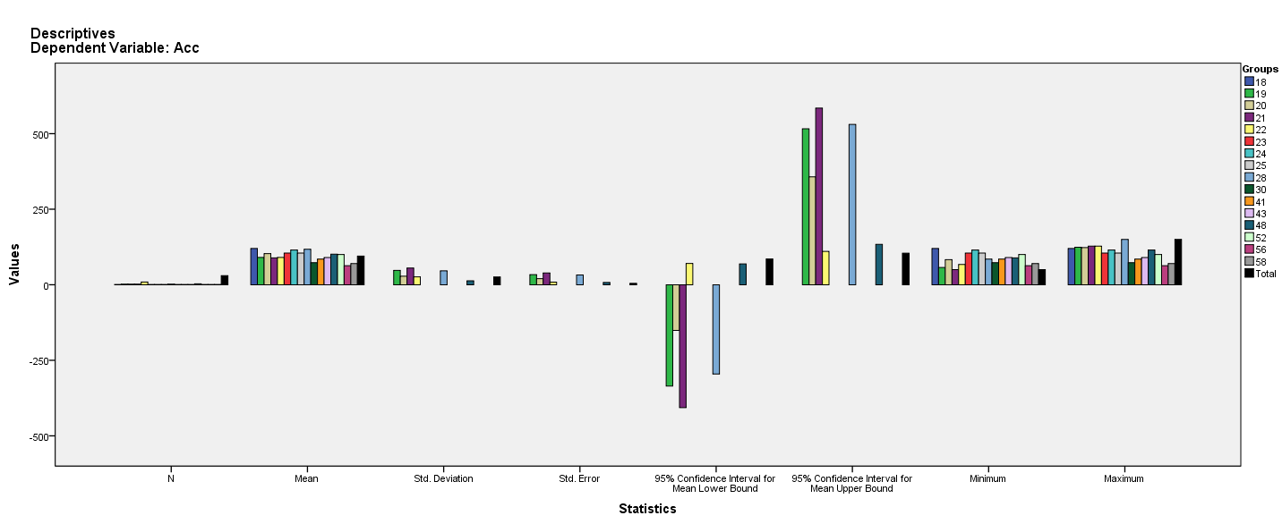

Test of Homogeneity of Variances
Acc
Levene Statistic | df1 | df2 | Sig.
4.863ª | 5 | 14 | .009
a. Groups with only one case are ignored in computing the test of homogeneity of variance for Acc.

ANOVA
Acc
 | Sum of Squares | df | Mean Square | F | Sig.
Between Groups | 5058.278 | 15 | 337.219 | .338 | .977
Within Groups | 13957.889 | 14 | 996.992
Total | 19016.167 | 29

Robust Tests of Equality of Means^{b}
Acc
 | Statisticª | df1 | df2 | Sig.
Welch | . | . | . | .
a. Asymptotically F distributed.
b. Robust tests of equality of means cannot be performed for Acc because at least one group has the sum of case weights less than or equal to 1.

Means Plots

